SMART WATER MANAGEMENT

Phase -2: Innovation

Introduction:

A smart water system is a cuttin-edge technological solution designed to revolutionize the way we manage and conserve water resources.By seamlessly integrating sensors,data analystic,and automation, smart water systems empower us to monitor, analyze,and optimize water usage in real time.

IoT programing algorithms:

1. Data collection: Gather historical water consumption date.This data can come from water meters,IoT devices,or utility records.
2. Data processing: clean and preprocess the data by handling missing values,outliners,and formatting it for machine learning.
3. Feature Engineering: create relevant features from the data.
4. User interface: which could be a mobile app or a web platform,to present water consumption.
5. Continuous learning: continuously update and retrain the model as new consumption data becomes available.
6. Feedback loop: Encourage users to provide feedback on the suggestions.
7. Algorithms selection: common choices include linear regression, decision trees, random forests.
8. Model training:split the data into training and testing sets and train your chosen machine learning model on the training data.
9. Prediction and analysis:Use the trained model to make predictions.
10. Conservation suggestions:The develop a system that generates conservation suggestions based on the model’s predictions.

Prototyping steps:

1.Design: Plan the system’s architecture, sensor placement,and communication protocols.

2.Hardware setup: Assemble the sensors, microcontroller,and communication module on a prototype board.

3.Coding: Write code for data collection, processing, user interface,and control logic.

4.Teating: Test the prototype with simulated or real water sources to ensure sensors work accurately.

5.Data Integration: Integrates data from multiple sources into a central database or cloud platform.

6.User Testing: Invite users to test the interface and provide feedback on usability.

7.Refinement: Make improvements based on user feedback and further testing.

8.Deployment:Deploy the prototype in a real-world environment for extended testing and evaluation.

9.Monitoring and maintenance: Continuously monitor and maintain the system to ensure its reliability.

Flow chart:

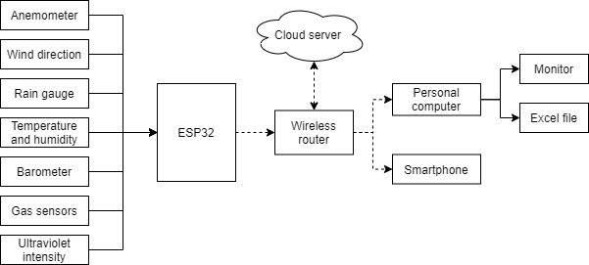

Implementation of smart water management:

1.Assessment:Begin by assessing your water usage patterns and identifying areas where water

Is wasted or inefficiently used.

2. Automation:Use smart controllers and actuators to automate water system.

3.Rain water Harvesting:Collect rainwater for non- potable uses like irrigation and flushing

Toilets.

4.Greywater Recycling: Implement greywater recycling systems to treat and reuse water

From sinks,showers,and laundry for my non-potable purposes.

5.Education and Awareness: Educate employees or residents about the importance of water conservation and provide tips on reducing water waste.

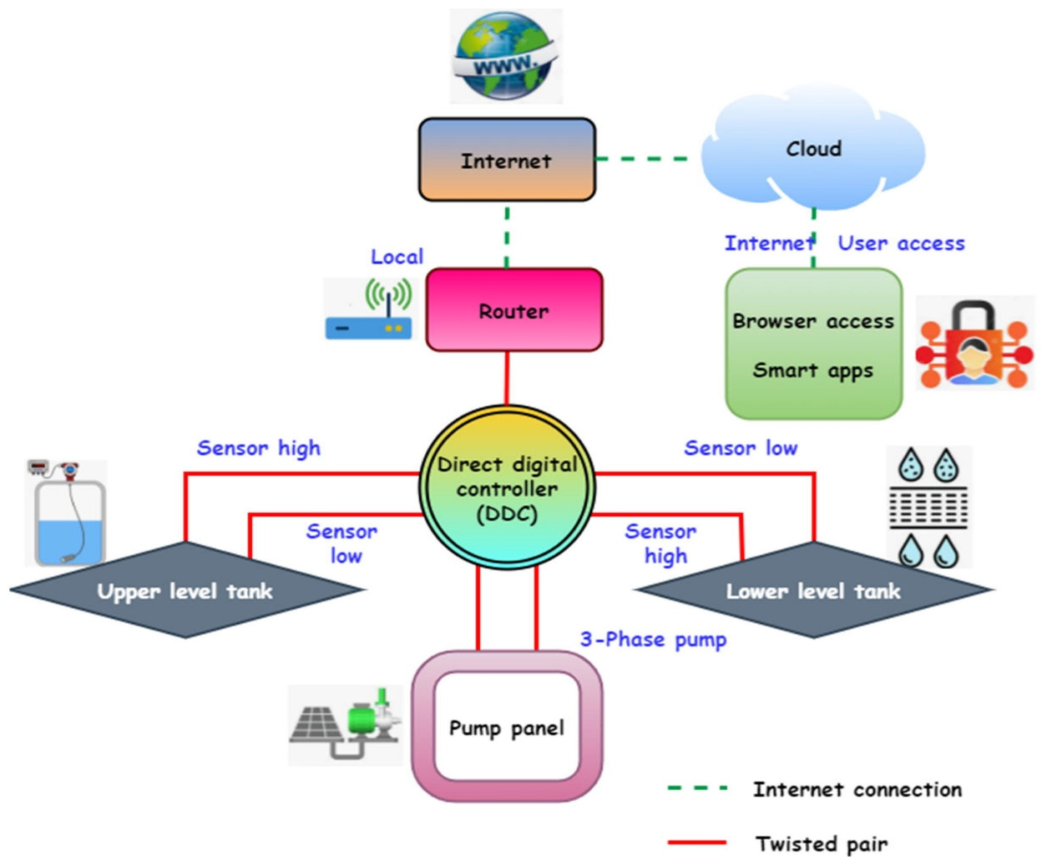 Assemble the sensors, microcontroller, and communication module on a prototype board.

Conclusion:

Our proposed system is truly based on IoT , using this system secure and continuous monitoring is possible no need to go on field for monitoring so manual work has been reduced it makes system more efficient, reliable,low cost and accurate.Data monitoring is easy from anywhere controlling is done automatically charging a flow rate.Flow rate is maintaining equally to changing a control valves position. Maintain a water quality by adding chlorine automatically and also automatically maintain a water level in main water tank.

_ _ _ _ _ _ _ _ _ _ _ _ _ _ _ _ _ _